5.2 System Configuration Utility

The System Configuration utility (**msconfig** command) is used to troubleshoot Windows startup problems by disabling startup programs and services one at a time or several at once. This graphical utility reduces the chances of making typing errors, deleting files, and other misfortunes that occur when technicians work from a command prompt. Only an administrator or a member of the Administrators group can use the System Configuration utility.

To start the System Configuration utility in Windows Vista/7, click *Start* > *Run* (or press the window *key plus* r) > type **msconfig** and press . In Windows 8 and 10, type **msconfig** in the search textbox. Figure 6.2.1 shows the System Configuration utility *General* tab.

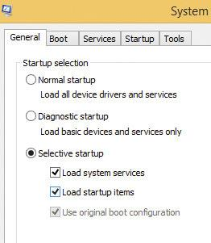

FIGURE 6.2.1: Windows 8 System Configuration utility: General tab

# General

*General* tab has three radio buttons: Normal startup, Diagnostic startup, and Selective startup

* *Normal startup* is the default option, and all device drivers and services load normally when this radio button is selected.
* The *Diagnostic startup* radio button is selected when you want to create a **clean environment for troubleshooting**. When *Diagnostic startup* is chosen and Windows is restarted, the system boots to Safe Mode and only the most basic device drivers and services are active.
* The *Selective startup* radio button is the **most common troubleshooting tab** on the General tab. When you choose *Selective startup*, you can pick which startup options load. Use the divide-and-conquer method of troubleshooting to find the startup file that is causing the boot problems. Start with the first checkbox, *Load system services*, and deselect the checkbox > *OK* and restart the computer. When you determine which file is causing the problem (the problem reappears), select the System Configuration tab that corresponds to the problem file and deselect files until the exact problem file is located.

# Boot

The *Boot* tab (see Figure 6.2.2) enables you to control and modify the Windows boot environment. The *Boot* tab functions include selecting the default operating system and the time allotted to wait for the default operating system to load if no other operating system is chosen from the boot menu in a multiple operating system situation. Notice how Safe boot and other options are available at the bottom of the window. Table 6.2.1 describes these options.

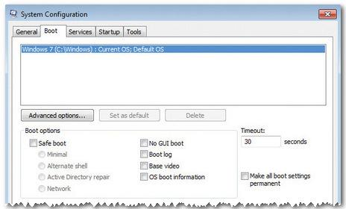

FIGURE 6.2.2: Windows 7 System Configuration utility: Boot tab

| **Safe boot option** | **Description** |
| --- | --- |
| Minimal | Boots in Safe Mode with only critical system services operational (no networking) |
| Alternate shell | Boots into a command prompt without GUI or networking |
| Active Directory repair | Boots into Safe Mode running critical system services and Active Directory |
| Network | Boots in Safe Mode GUI with networking enabled |
| No GUI | Does not display the Windows welcome screen |
| Boot log | Stores information about the startup process in the **ntbtlog .txt** file |
| Base video | Starts in VGA mode |
| OS boot information | Displays driver names during the boot process |
| Timeout | Controls how long the boot menu shows before the default boot entry executes |

TABLE 6.2.1: System Configuration Boot Tab > Safe boot Options

# Services

The *Services* and *Startup* tabs in the System Configuration window are also quite useful when troubleshooting boot problems. Certain applications, such as an antivirus program or the printer, run as services. Many of these services are started during the boot process. Use the *Services* tab (see Figure 6.2.3) to disable and enable these boot services. Enable the *Hide all Microsoft Services* option to view and manipulate third-party (non-Microsoft) services.

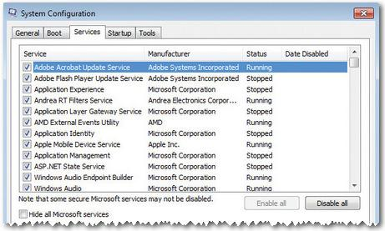

FIGURE 6.2.3: Windows 7 System Configuration utility: Services tab

# Startup

The *Startup* tab enables you to enable and disable Windows-based startup programs. Figure 6.2.4 shows a sample Startup tab screen.

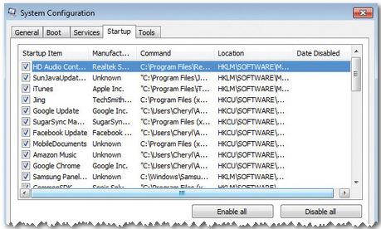

FIGURE 6.2.4: Windows 7 System Configuration utility: Startup tab

In Windows Vista and Windows 7 startup options are controlled in the *Startup* tab. However, in Windows 8 and 10, this tab links you to Task Manager (covered next) to manage startup items.

# Tools

The System Configuration *Tools* tab allows launching such options as Task Manager, Performance Monitor, and Internet Options from Internet Explorer—items that might need to be changed as a result of a startup issue.

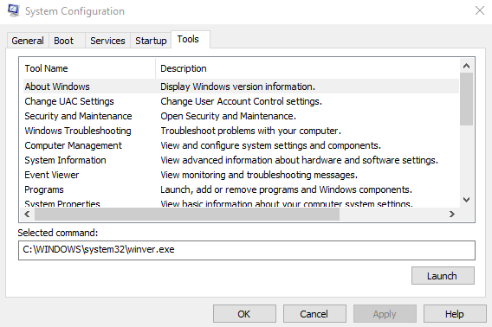

FIGURE 6.2.5: Windows 10 System Configuration utility: Tools tab

# Summary

The main things you will want to look in msconfig are the non-Microsoft services and the startups. You can also check out the shortcut tools provided by it.